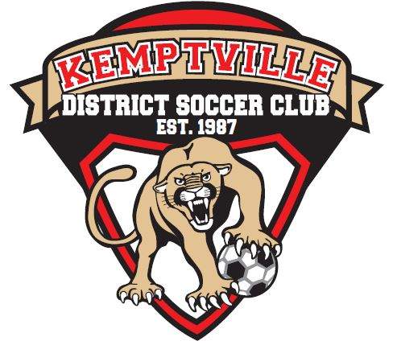

KDSC 2023 AGM Agenda
October 24, 2023, at 19:00
North Grenville Community Center Suite B

Credentials Report

Approve Draft Minutes of 2022 AGM

President’s Report

Treasurer’s Report

Appointment of Auditor for 2024 Financial Audit

Other Reports
- Club Head Coach Report
- Club Head Referee Report

Unfinished Business

Amendments to Constitution and Bylaws

Election of Officers and Directors:
The positions for election at the 2023 AGM:
- President (1 year term as currently the role is unfilled)
- Vice-President (2-year term)
- Treasurer (1 year term as current Treasurer is stepping down after the 2023 season)
- Director of Registration (2-year term)
- Director of House League (2-year term)
- Director of Mini Soccer (1 year term as currently the role is unfilled)
- Director of Development Teams (2-year term)
- Director of Equipment Competitive (2-year term)

Other Business

Adjournment and Setting of the Next KDSC Board Meeting

